Homework1-5

Xiongling zhang 27720161153033

Homework1
Question1
This is the development path of memory of PCs
Corresponding code
year<c(1988,1991,1996,2000,2003,2007,2014)
RAM<-c(0.002,0.004,0.5,1,2,8,16)
plot(year,RAM,ylab = "")
title(main ="How the memory of pc changes over the last 30 years",ylab = "RAM(G)")
lines(spline(year,RAM))
lines(spline(year,RAM, n = 201), col = 2)
Twenty years ago,the memory of pc is too small to support the analysis of FMRY

Question2
Logistic regression:
In statistics, logistic regression, or logit regression, or logit model[1] is a regression model where the dependent variable (DV) is categorical. This article covers the case of a binary dependent variable—that is, where the output can take only two values, "0" and "1", which represent outcomes such as pass/fail, win/lose, alive/dead or healthy/sick. Cases where the dependent variable has more than two outcome categories may be analysed in multinomial logistic regression, or, if the multiple categories are ordered, in ordinal logistic regression.[2] In the terminology of economics, logistic regression is an example of a qualitative response/discrete choice model.

A example:Probability of passing an exam versus hours of study
Suppose we wish to answer the following question:
A group of 20 students spend between 0 and 6 hours studying for an exam. How does the number of hours spent studying affect the probability that the student will pass the exam?
The reason for using logistic regression for this problem is that the dependent variable pass/fail represented by "1" and "0" are not cardinal numbers. If the problem was changed so that pass/fail was replaced with the grade 0–100 (cardinal numbers), then simple regression analysis could be used.
The table shows the number of hours each student spent studying, and whether they passed (1) or failed (0)

The graph shows the probability of passing the exam versus the number
of hours studying, with the logistic regression curve fitted to the data.
The logistic regression analysis gives the following output.

Homework2
Question 1
Code:
x = 6
n = 1000
lambda = 2
p = lambda / n
dbinom (x,2*n,p) # binomial probability mass function
dpois (x, 2*lambda ) # Poisson probability mass function
dpois (0, 5 )

Question 2
Code:
plot(year,number,type = "b",
col="black",main = "The history of computer memory",
sub = "This is the change in the number of types of computer memory",
xlab = "year",ylab = "The number of memory")
barplot(number,
xlab = "year",ylab ="The number of memory ")

Question3
Code:
lambda=2
x=seq(0:6)
P<-data.frame(dpois(x,lambda))
sum<-(P[1,]+P[7,]+P[2,]+P[6,]+P[3,]+P[5,]+P[4,]+P[4,])
sum
lambda=5
x=0
dpois(x,lambda)

Homework3
Question 1
library("digest")
# now do the hash code calculation
digest("I learn a lot from this class when I am proper listening to the professor")
digest("I do not learn a lot from this class when I am absent and playing on my Iphone")

Question 2
What is DSA?
• Digital signatures are essential to verify the sender of a document’s identity. The signature is computer using a set of rules and algorithm such that the identity of the person can be verified.
• The signature is generated by the use of a private key that known only to the user. The signature is verified when a public key is corresponds to the private key. With every user having a public/private key pair, this is an example of public-key cryptography.
• Public keys, which are known by everyone, can be used to verify the signature of a user. The private key, which is never shared, is used in signature generation, which can only be done by the user.

What can DSA do?
•Digital signatures are used to detect unauthorized modifications to data. Also, the recipient of a digitally signed document in proving to a third party that the document was indeed signed by the person who it is claimed to be signed by. This is known as nonrepudiation, because the person who signed the document cannot repudiate the signature at a later time.
•Digital signature algorithms can be used in e-mails, electronic funds transfer, electronic data interchange, software distribution, data storage, and just about any application that would need to assure the integrity and originality of dat

Question 3
R-code:
>library(RJSONIO)
> letter<-LETTERS[1:10]
>country<-c("China","the US","the UK","Russia",
"Korea","Japan","Italy","Brazil","India","Germany")
> data<-data.frame(letter,country)
> da<-as.matrix(data)
>cat(toJSON(da))

Question 4

Homewor4
Question1

Q1. Improve the R quantlets on GH (from CRIX directory on quantlet.de) and make excellent graphics that follow Fig 3,4,5,6 of the ”Econometrics of CRIX“ paper.

rm(list = ls(all = TRUE))
graphics.off()
# install and load packages
libraries = c("zoo", "tseries", "xts","ccgarch")
lapply(libraries, function(x) if (!(x %in% installed.packages())) { install.packages(x)}

lapply(libraries, library, quietly = TRUE, character.only = TRUE)
# load dataset
load(file.choose())
load(file.choose())
load(file.choose())
# three indices return
ecrix1 = zoo(ecrix, order.by = index(crix1))
efcrix1 = zoo(efcrix, order.by = index(crix1))
# plot with different x-axis scales with zoo
my.panel <- function(x, ...) {
lines(x, ...)
lines(ecrix1, col = "blue")
lines(efcrix1, col = "red")
}
plot.zoo(crix1, plot.type = "multiple", type = "l", lwd = 1.5, panel = my.panel,
main = "Indices in the CRIX family", xlab = "Date")

# plot of crix
# plot(as.xts(crix), type="l", auto.grid=FALSE, main = NA)
plot(crix1, ylab = "Price of CRIX", xlab = "Date")
# plot of crix return
ret = diff(log(crix1))
# plot(as.xts(ret), type="l", auto.grid=FALSE, main = NA)
plot(ret, ylab = "Return of CRIX", xlab = "Date")
# stationary test
adf.test(ret, alternative = "stationary")
kpss.test(ret, null = "Trend")
par(mfrow = c(1, 2))
# histogram of returns
hist(ret, col = "grey", breaks = 20, freq = FALSE, ylim = c(0, 25), xlab = "Return of CRIX")
lines(density(ret), lwd = 2)
mu = mean(ret)
sigma = sd(ret)
x = seq(-4, 4, length = 100)
curve(dnorm(x, mean = mean(ret), sd = sd(ret)), add = TRUE, col = "red",
lwd = 2)

# qq-plot
qqnorm(ret)
qqline(ret, col = "blue", lwd = 3)
# acf plot
autocorr = acf(ret, lag.max = 20, ylab = "Sample Autocorrelation", main = "acf plot",
lwd = 2, ylim = c(-0.3, 1))
# pacf plot
autopcorr = pacf(ret, lag.max = 20, ylab = "Sample Partial Autocorrelation",
main = "pacf plot", ylim = c(-0.3, 0.3), lwd = 2)

Question 2

Q2. Make your R code perfect as in the R examples on quantlet.de i.e. make sure that the code is ”time independent“ by using actual dimensions of the data that you are collecting from crix.hu-berlin.de Recreate Fig 7 from ”Econometrics of CRIX“.

Codes:
# arima model
par(mfrow = c(1, 1))
fit1 = arima(ret, order = c(1, 0, 1))
tsdiag(fit1)
Box.test(fit1$residuals, lag = 1)
# aic
aic = matrix(NA, 6, 6)
for (p in 0:4) {
for (q in 0:3) {
a.p.q = arima(ret, order = c(p, 0, q))
aic.p.q = a.p.q$aic
aic[p + 1, q + 1] = aic.p.q
}
}

# bic
bic = matrix(NA, 6, 6)
for (p in 0:4) {
for (q in 0:3) {
b.p.q = arima(ret, order = c(p, 0, q))
bic.p.q = AIC(b.p.q, k = log(length(ret)))
bic[p + 1, q + 1] = bic.p.q
}
}
# select p and q order of ARIMA model
fit4 = arima(ret, order = c(2, 0, 3))
tsdiag(fit4)
Box.test(fit4$residuals, lag = 1)
fitr4 = arima(ret, order = c(2, 1, 3))
tsdiag(fitr4)
Box.test(fitr4$residuals, lag = 1)

# to conclude, 202 is better than 213
fit202 = arima(ret, order = c(2, 0, 2))
AIC(fit202, k = log(length(ret)))
AIC(fit4, k = log(length(ret)))
AIC(fitr4, k = log(length(ret)))
fit202$aic
fit4$aic
fitr4$aic
# arima202 predict
predict_num = 30
fit202 = arima(ret, order = c(2, 0, 2))
crpre = predict(fit202, n.ahead = predict_num)
dates = seq(as.Date("02/08/2014", format = "%d/%m/%Y"), by = "days", length = length(ret))
plot(ret, type = "l", xlim = c(0, length(ret)+predict_num), ylab = "log return", xlab = "days",
lwd = 1.5, col = "black")
lines(crpre$pred, col = "red", lwd = 3)
lines(crpre$pred + 2 * crpre$se, col = "red", lty = 3, lwd = 3)
lines(crpre$pred - 2 * crpre$se, col = "red", lty = 3, lwd = 3)

Question3

Codes:
rm(list = ls(all = TRUE))
graphics.off()
# install and load packages
libraries = c("tseries")
lapply(libraries, function(x) if (!(x %in% installed.packages())) {
install.packages(x)
})
lapply(libraries, library, quietly = TRUE, character.only = TRUE)
# please change your working directory
setwd()
load(file.choose())
Pr = as.numeric(crix)
Da = factor(date1)
crx = data.frame(Da, Pr)
# plot of crix return
ret = diff(log(crx$Pr))
Dare = factor(date1[-1])
retts = data.frame(Dare, ret)
# arima202 predict
fit202 = arima(ret, order = c(2, 0, 2))

# vola cluster
par(mfrow = c(1, 1))
res = fit202$residuals
res2 = fit202$residuals^2
tsres202 = data.frame(Dare, res2)
plot(tsres202$Dare, tsres202$res2, type = "o", ylab = NA)
lines(tsres202$res2)
# plot(res2, ylab='Squared residuals', main=NA)
par(mfrow = c(1, 2))
acfres2 = acf(res2, main = NA, lag.max = 20, ylab = "Sample Autocorrelation", lwd = 2)
pacfres2 = pacf(res2, lag.max = 20, ylab = "Sample Partial Autocorrelation", lwd = 2, main = NA)

Codes:
rm(list = ls(all = TRUE))
graphics.off()
# install and load packages
libraries = c("forecast", "fGarch")
lapply(libraries, function(x) if (!(x %in% installed.packages())) {
install.packages(x)
})
lapply(libraries, library, quietly = TRUE, character.only = TRUE)
# load dataset
load(file.choose())
ret = diff(log(crix1))
# vol cluster
fit202 = arima(ret, order = c(2, 0, 2))
par(mfrow = c(1, 1))
res = fit202$residuals
res2 = fit202$residuals^2

# different garch model
fg11 = garchFit(data = res, data ~ garch(1, 1))
summary(fg11)
fg12 = garchFit(data = res, data ~ garch(1, 2))
summary(fg12)
fg21 = garchFit(data = res, data ~ garch(2, 1))
summary(fg21)
fg22 = garchFit(data = res, data ~ garch(2, 2))
summary(fg22)
# residual plot
reszo = zoo(fg11@residuals, order.by = index(crix1))
plot(reszo, ylab = NA, lwd = 2)

par(mfrow = c(1, 2))
fg11res2 = fg11@residuals
acfres2 = acf(fg11res2, lag.max = 20, ylab = "Sample Autocorrelation",
main = NA, lwd = 2)
pacfres2 = pacf(fg11res2, lag.max = 20, ylab = "Sample Partial Autocorrelation",
main = NA, lwd = 2, ylim = c(-0.5, 0.5))
fg12res2 = fg12@residuals
acfres2 = acf(fg12res2, lag.max = 20, ylab = "Sample Autocorrelation",
main = NA, lwd = 2)
pacfres2 = pacf(fg12res2, lag.max = 20, ylab = "Sample Partial Autocorrelation",
main = NA, lwd = 2, ylim = c(-0.5, 0.5))
# qq plot
par(mfrow = c(1, 1))
plot(fg11, which = 13) #9,10,11,13

Codes:
fg11stu = garchFit(data = res, data ~ garch(1, 1), cond.dist = "std")
# different forecast with t-garch
# fg11stufore = predict(fg11stu, n.ahead = 30, plot=TRUE, mse='uncond', auto.grid=FALSE)
fg11stufore = predict(fg11stu, n.ahead = 30, plot = TRUE, cond.dist = "QMLE",
auto.grid = FALSE)
par(mfrow = c(1, 2))
stu.fg11res2 = fg11stu@residuals
# acf and pacf for t-garch
stu.acfres2 = acf(stu.fg11res2, ylab = NA, lag.max = 20, main = "ACF of Squared Residuals",
lwd = 2)
stu.pacfres2 = pacf(stu.fg11res2, lag.max = 20, main = "PACF of Squared Residuals",
lwd = 2, ylab = NA, ylim = c(-0.5, 0.5))
# ARIMA-t-GARCH qq plot
par(mfrow = c(1, 1))
plot(fg11stu, which = 13)

Homework 5
Question1
rm(list = ls())
#install.packages("RCurl")
#install.packages("XML")
library(RCurl)
library(XML)
url1 = "http://shakespeare.mit.edu/romeo_juliet/full.html"
url2 = "http://shakespeare.mit.edu/julius_caesar/full.html"
url3 = "http://shakespeare.mit.edu/hamlet/full.html"
html1 = readLines(url1, encoding = "UTF-8")
html2 = readLines(url2, encoding = "UTF-8")
html3 = readLines(url3, encoding = "UTF-8")
html1 = htmlParse(html1, encoding = "UTF-8")
html2 = htmlParse(html2, encoding = "UTF-8")
html3 = htmlParse(html3, encoding = "UTF-8")
#install.packages("bitops")
#install.packages("stringr")
library(bitops)
library(stringr)
abs1 = lapply(url1, FUN = function(x) htmlParse(x, encoding = "Latin-1"))
abs2 = lapply(url2, FUN = function(x) htmlParse(x, encoding = "Latin-1"))
abs3 = lapply(url3, FUN = function(x) htmlParse(x, encoding = "Latin-1"))
clean_txt = function(x) {
cleantxt = xpathApply(x, "//body//text()
[not(ancestor :: script)][ not(ancestor :: style)]
[not(ancestor :: noscript)] " ,xmlValue)
cleantxt = paste(cleantxt, collapse="\n")
cleantxt = str_replace_all(cleantxt, "\n", " ")
cleantxt = str_replace_all(cleantxt, "\r", "")
cleantxt = str_replace_all(cleantxt, "\t", "")
cleantxt = str_replace_all(cleantxt, "<br>", "")
return(cleantxt)
}
cleantxt1 = lapply(abs1,clean_txt)
cleantxt2 = lapply(abs2,clean_txt)
cleantxt3 = lapply(abs3,clean_txt)
vec_abs1 = unlist(cleantxt1)
vec_abs2 = unlist(cleantxt2)
vec_abs3 = unlist(cleantxt3)
#install.packages("tm")
#install.packages("SnowballC")
library(tm)
library(SnowballC)
abs1 = Corpus(VectorSource(vec_abs1))
abs2 = Corpus(VectorSource(vec_abs2))
abs3 = Corpus(VectorSource(vec_abs3))
abs_dtm1 = DocumentTermMatrix(abs1, control = list(
stemming = TRUE, stopwords = TRUE, minWordLength = 3,
removeNumbers = TRUE, removePunctuation = TRUE))
abs_dtm2 = DocumentTermMatrix(abs2, control = list(
stemming = TRUE, stopwords = TRUE, minWordLength = 3,
removeNumbers = TRUE, removePunctuation = TRUE))
abs_dtm3 = DocumentTermMatrix(abs3, control = list(
stemming = TRUE, stopwords = TRUE, minWordLength = 3,
removeNumbers = TRUE, removePunctuation = TRUE))
##WordCloud
instal.packages("ggplot2")
install.packages("wordcloud")
library(ggplot2)
library(wordcloud)
freq1 = colSums(as.matrix(abs_dtm1))
freq2 = colSums(as.matrix(abs_dtm2))
freq3 = colSums(as.matrix(abs_dtm3))
wf1 = data.frame(word=names(freq1), freq=freq1)
wf2 = data.frame(word=names(freq2), freq=freq2)
wf3 = data.frame(word=names(freq3), freq=freq3)
#Romeo and Juliet
plot1 = ggplot(subset(wf1, freq>15), aes(word, freq1))
plot1 = plot1 + geom_bar(stat="identity")
plot1 = plot1 + theme(axis.text.x=element_text(angle=45, hjust=1))
plot1
freq1 = colSums(as.matrix(abs_dtm1))
dark2_1 = brewer.pal(6, "Dark2")
wordcloud(names(freq1), freq1, max.words=100, rot.per=0.2, colors=dark2_1)
#Julius Caeser
plot2 = ggplot(subset(wf2, freq>15), aes(word, freq2))
plot2 = plot2 + geom_bar(stat="identity")
plot2 = plot2 + theme(axis.text.x=element_text(angle=45, hjust=1))
plot2
freq2 = colSums(as.matrix(abs_dtm2))
dark2_2 = brewer.pal(6, "Dark2")
wordcloud(names(freq2), freq2, max.words=100, rot.per=0.2, colors=dark2_2)
#Hamlet
plot3 = ggplot(subset(wf3, freq>15), aes(word, freq3))
plot3 = plot3 + geom_bar(stat="identity")
plot3 = plot3 + theme(axis.text.x=element_text(angle=45, hjust=1))
plot3
freq3 = colSums(as.matrix(abs_dtm3))
dark2_3 = brewer.pal(6, "Dark2")
wordcloud(names(freq3), freq3, max.words=100, rot.per=0.2, colors=dark2_3)
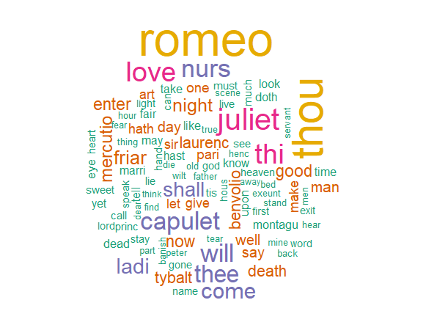
Figure 1: Romeo and Julia

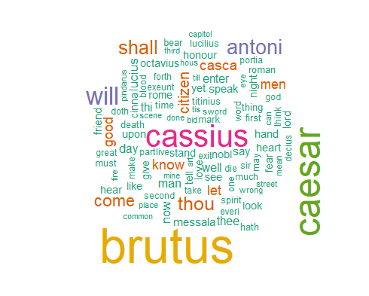
Figure 2: Julius Caesar

Question2
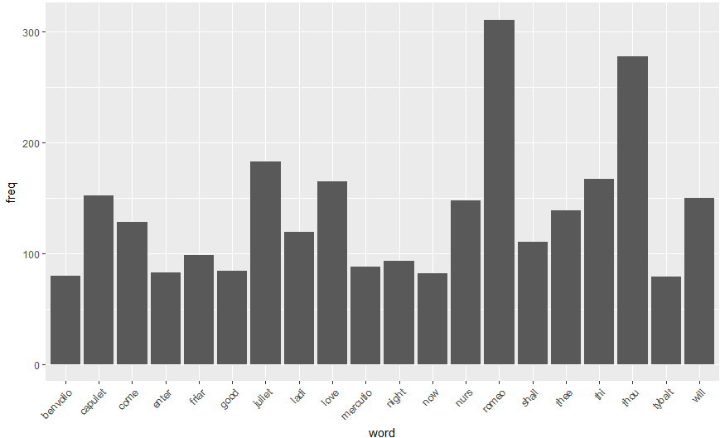
Figure 4: Romeo and Julia

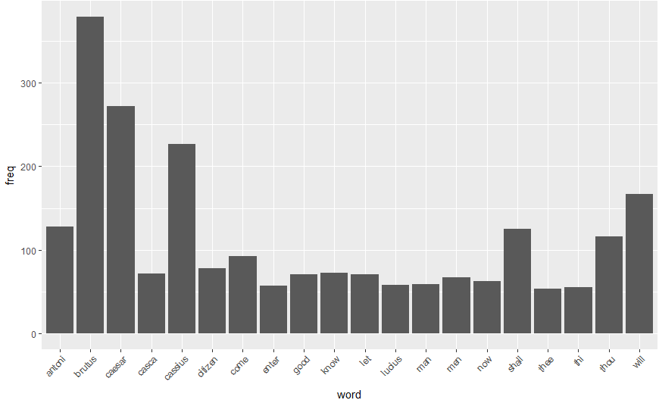
Figure 5: Julius Caesar

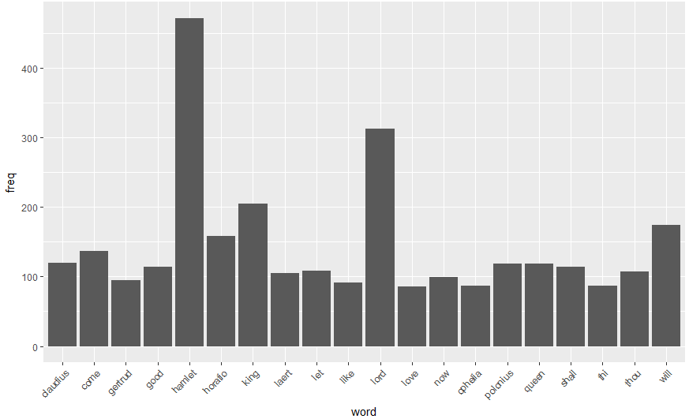
Figure 6: Hamlet

